FOP LAB ASSIGNMENT – I

Q1. Write a C++ program, take two strings as input from user and check if both strings are equal or not. If they are equal make them unequal by rotating string. e.g., Hello is turned into olleH etc.

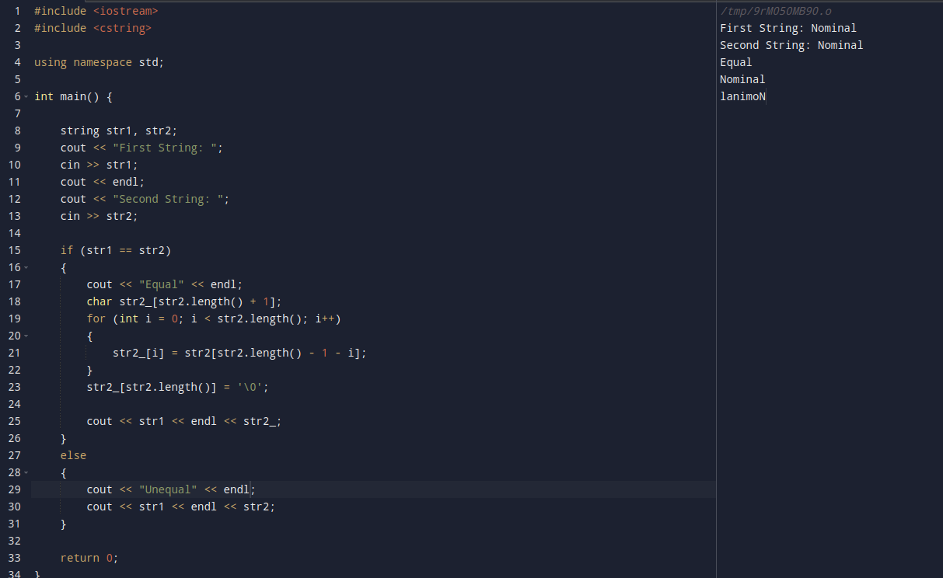
Q2. Write a C++program for a string which may contain lowercase and uppercase
characters. The task is to remove all duplicate characters from the string and find
the resultant string.

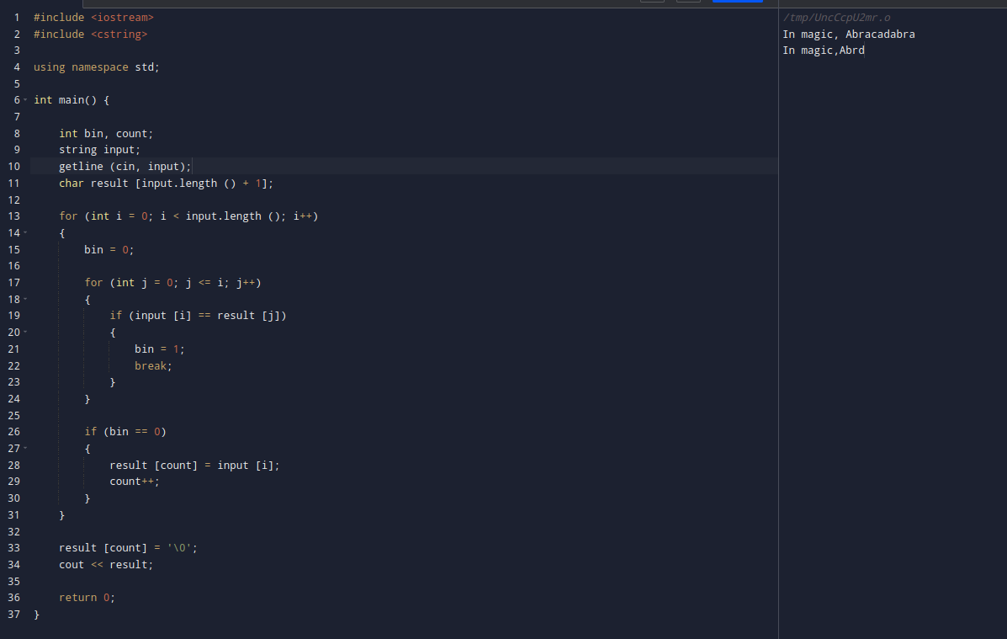
Q3. Suppose an integer array a[5] = {1,2,3,4,5}. Add more elements to it and display them in C++.

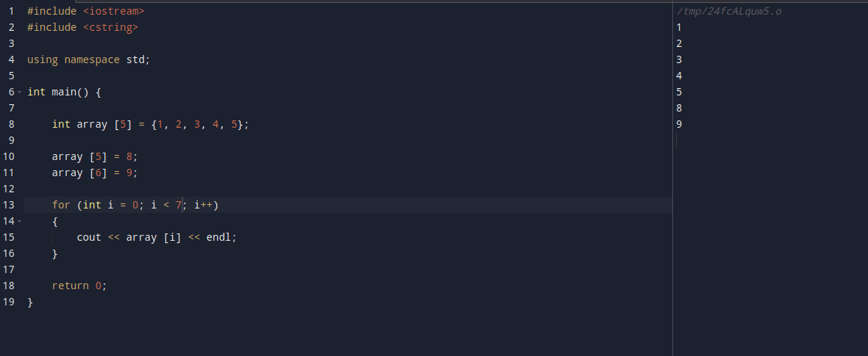
Q4. Write a C++ program that uses a while loop to find the largest prime number less
than a given positive integer N. Your program should take the value of N as input
from the user and then find the largest prime number less than or equal to N. You
are not allowed to use any library or pre-existing functions to check for prime
numbers.

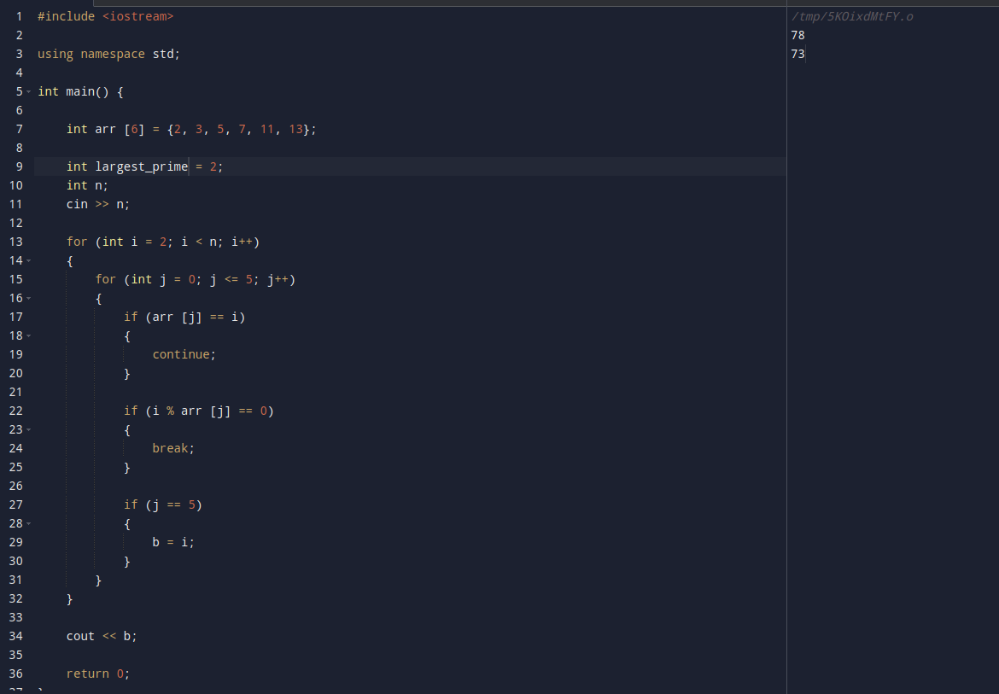
Q5. Implement Bubble Sort on an array of 6 integers.

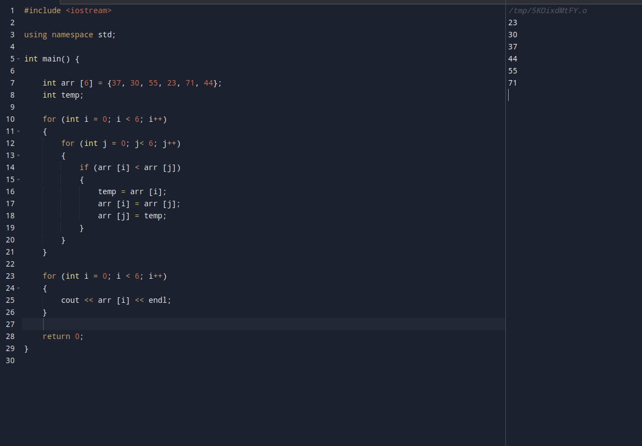
Q6. For an aircraft flying towards a location it has to drop a payload on, using as input the required values, determine the acceleration required such that if the payload were to be dropped now, it would land on the target. You may assume no air resistance.

